Assessment Brief

Candidate Name:  Gareth Craig | Centre Name:  Letterkenny Training Centre, Ramelton Rd, Ballyraine Industrial Estate, Letterkenny, Co. Donegal
City and Guilds Number: | Centre Number:  079065

Date: 13/12/2019



1. Implement a Software Design Using Procedural Programming
1.1 Identify the program modules and data and file structures required to implement your design
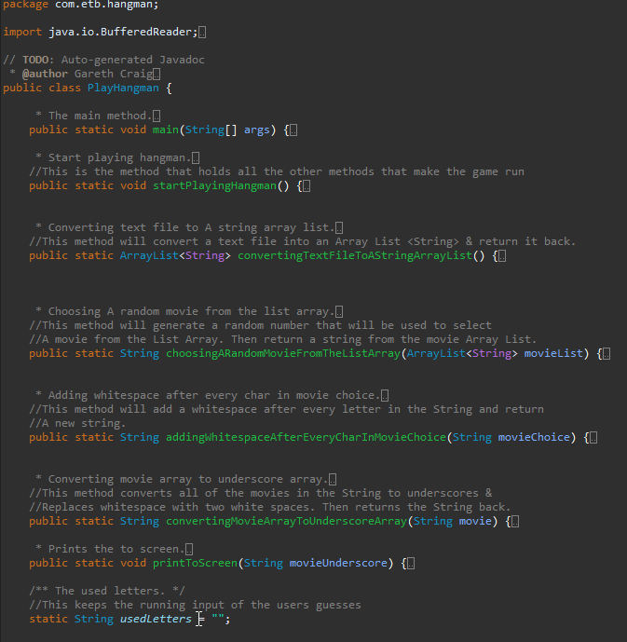

1.2 Select, declare and initialise variable and data structure types and sizes to implement design requirements
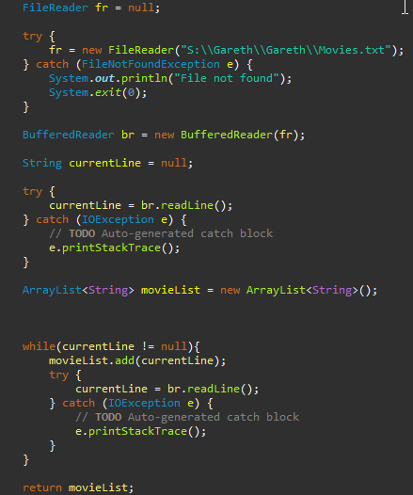

1.3 Select and implement control structures to meet the design algorithms
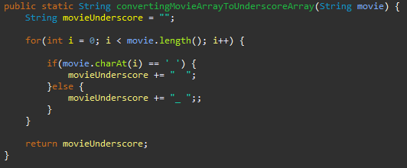

1.4 Select and declare file structures to meet design file storage requirements

1.5 Evidence your use of standard input/output commands to implement design requirements
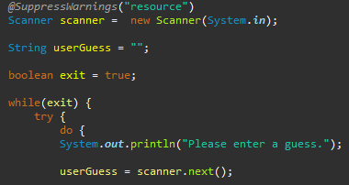

1.6 Explain and give examples of the use of operators and predefined functions

1.7 Explain and give examples of your use of parameter passing mechanisms
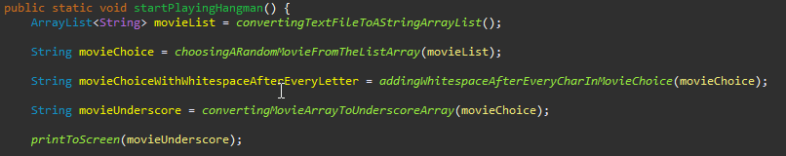
2. Refine a procedural program to improve quality
2.1 Explain and demonstrate your use of agreed standard for naming, comments and code layout
2.2 Give an example of code which replaces repeating code sequences (loops)
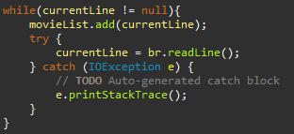

2.3 Give examples of data validation methods for inputs
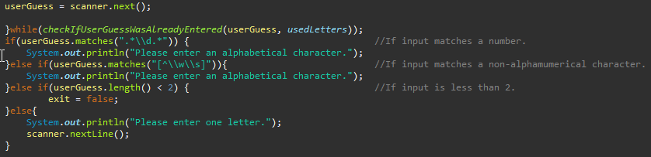

2.4 Explain and give example(s) of error handling and reporting.

3. Test the operation of a procedural program

3.1 Make effective use of available debugging tools
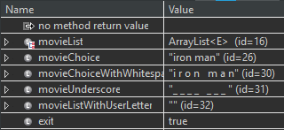
The following screenshot shows the use of Eclipse debugging tool.
3.2 Prepare a test strategy - This will include explanations of how you plan to test your application as well as your test cases
I will test to see if the user can input more than one character, if they can enter a numerical value, a special character and if a capitalized letter will give a different result. I will also make sure that the data being read in from the text file is being displayed correctly and also with the use of the debugging tool, make sure that I can see that each of my methods are doing what I expect them to do. The test cases will cover all the ranges of user inputs and as well as if the data is being read correctly.
3.3 Select suitable test data and determine expected test results
See spreadsheet
3.4 Record actual test results to enable comparison with expected results
See spreadsheet
3.5 Analyse actual test results against expected results to identify discrepancies (Pass fails)
See spreadsheet
3.6 Investigate test discrepancies to identify and rectify their causes. (Show any errors you have found and your fixes)
See spreadsheet

4. Document a computer programme

4.1 Create documentation to assist the users of a computer program
4.2 Create documentation for the support and maintenance of a computer program.
5. Appendix
5.1 Program Listing

